Kerman Space Systems

R-3 Series of Carrier Rocket

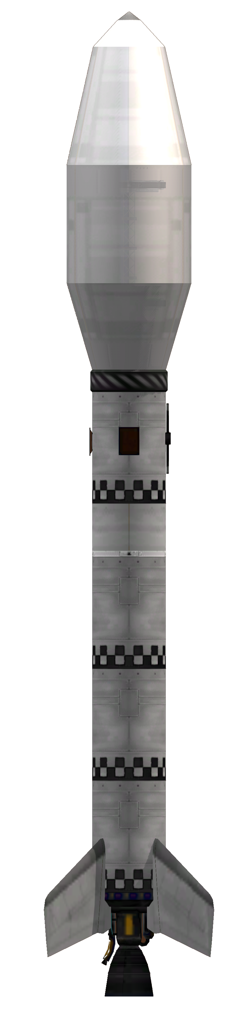
Operator’s Manual, volume 1
Launcher assembly
TABLE OF CONTENTS

R-3 family description
The R-3 rockets are 2 stage rockets designed as a payload carrier for ground to low Kerbin orbit. These rockets are designed to deliver a payload of up to 3.2 tonnes to an 80 KM circular orbit.
The rocket comes with a standard payload section, simplifying performance calculations. The most relevant parameter for performance calculation for a specific fairing type is payload mass.

Vehicle coordinate data
The launch vehicle coordinate system is comprised of three axes. Using these axes, directions can be unambiguously referenced in this manual.
The X axis runs along the body of the rocket. It is also known as the roll axis. A clockwise movement, as seen into the vehicle’s nozzles is defined as a “right roll”, while the opposite roll is defined as a “left roll”. These movements correspond to the input controls and the response of the navball.
The two remaining axes delimit the sides of the rocket. The Z axis defines the left and right sides. Rotating over the Y axis, causing the nose to point to the +Z direction is called a “right yaw” while the opposite movement is a “left yaw”. Rotating over the Z axis to point the nose to the +Y direction is a “pitch up” maneuver, while the opposite is a “pitch down”. These movements correspond to the yaw and pitch movements caused by acting on the respective controls and the corresponding navball response.
Additionally, the +Z side is called the “east” side, the -Z side is called “west” and the +Y and -Y are called “south” and “north” respectively. These shorthand definitions correspond to the cardinal directions faced by each side, when sitting on the pad waiting to launch, and is used to identify each upper stage hardpoint.
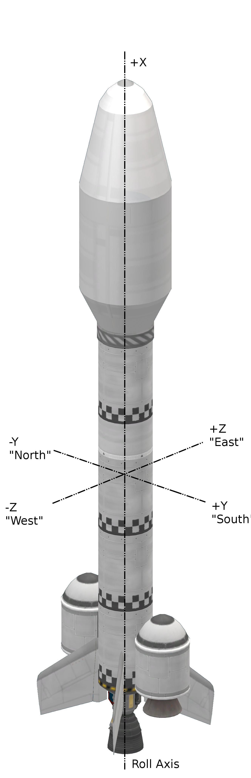
The +Z and -Z sides are also called the “right” and “left” side during the autopilot program descriptions.

R-3 series ID codes
R-3 rockets are identified by the following alphanumerical code.

R3-(400,800,1200,1200B,1200L)-(F,C,S,D)(1,2,3,4,5)-(N,O,J,H)(0,1,2)(0,1)(N,O,P,Q)(0,1,2)(X,R)

These codes describe the features of each specific rocket type and should be interpreted in the following way.

R3-(Type)-(Payload Section)-(Avionics)

The R3 string defines the base rocket family. Strings other than R3 represent different rocket families, specified in other documents. This identifying string is left constant for all members of this launch vehicle family.
The type defines which specific member of the R-3 family is being described. There are 5 members of the R-3 family.

Rocket type code | Description
400 | Ultra short launch vehicle, for very light payloads
800 | Shorter launch vehicle
1200 | Baseline launch vehicle
1200B | Boosted 1200 model, two solid fueled boosters
1200L | Booster 1200 model, two liquid fueled boosters

The payload definition is a two letter code describing the arrangement of payload bay and fairing type. The payload bay definition comes first, followed by a fairing definition.

Bay code | Description
F | Payload affixed to fairing base, integral to upper stage
C | Capsule service module, no avionics bay
S | Single payload with avionics bay
D | Dual payloads with avionics bay

The fairing definition is shown below.
Fairing code | Description
1 | Kerman Space Systems fairing type A1
2 | Kerman Space Systems fairing type A2
3 | Kerman Space Systems fairing type A3
4 | Kerman Space Systems fairing type B1
5 | Kerman Space Systems fairing type B2

Types 1 to 3 fairings are used for general cargo, while fairing types 4 (B1) and 5 (B2) are used for manned capsules. Rocket type C4 has been designed with the AOC-3 capsule in mind, while type C5 is suited for launching the AOC-2 capsule. See their respective manuals for details.

Immediately after the payload section definition comes the avionics description code. This code describes the launch vehicle’s avionics. Each letter describes a particular system, and has several variants described in the table below. Avionics are mounted in the avionics bay inside the fairing or in 4 hardpoints, radially, connected to the upper stage fuel tank.
System | Code | Definition
On board computer | N | No OBC. Guidance depends on payload computer.
On board computer | J | MechJeb2 AR202 case in west upper stage hardpoint.
On board computer | O | Probodobodyne OKTO in payload bay.
On board computer | H | Probodobodyne HECS in payload bay.
Stabilization | 0 | No reaction wheels, except as provided by OBC.
Stabilization | 1 | Small reaction wheel in avionics bay.
Stabilization | 2 | Advanced Inline Stabilizer in avionics bay.
Communications | 0 | Payload communications only.
Communications | 1 | Communotron-16S in east upper stage hardpoint.
Power generation | N | No power supply, power provided only by batteries.
Power generation | O | 2 OX-STAT solar panels radially attached to north/south sides.
Power generation | P | 1 OX-STAT solar panel radially attached to west side.
Power generation | Q | Model O and P panels.
Power storage | 0 | On board computer and payload batteries only
Power storage | 1 | Z-200 battery bank in avionics bay
Power storage | 2 | Z-1K battery bank in avionics bay
Reusability | X | Expendable.
Reusability | R | Single MK16 parachute in avionics bay.

R-3 rocket assembly
R-3 rockets should normally be taken from a template, resorting to manual assembly only if a template is not available. The use of a template ensures consistency in performance and physical characteristics.
After manual assembly and testing of an R-3 model, we recommend saving the result as a template.
Boosted variants should be extensively tested to ensure proper booster aerodynamic characteristics during ejection.

Lower stage

Sustainer core assembly
Take a LV-T30 “Reliant” liquid fueled engine and place in the VAB building. Ensure that it is set to full thrust.
Take the necessary number of “dark” themed FL-T400 fuel tanks (1 for the R-3-400, 2 for the R-3-800 and 3 for the R-3-1200) and stack them axially above the engine, one above the next. Other types of fuel tanks are not recommended, as using the same tank type for all variants simplifies the conversion between models and other tank models may also lack important markings used in as reference during assembly.
Take a TD-12 decoupler and stack axially above the topmost fuel tank.

Sustainer fin installation
Fin assembly should be done using 4-way radial symmetry. The installation should be done simultaneously on all 4 fins, and manual installation (one at a time) should not be used.
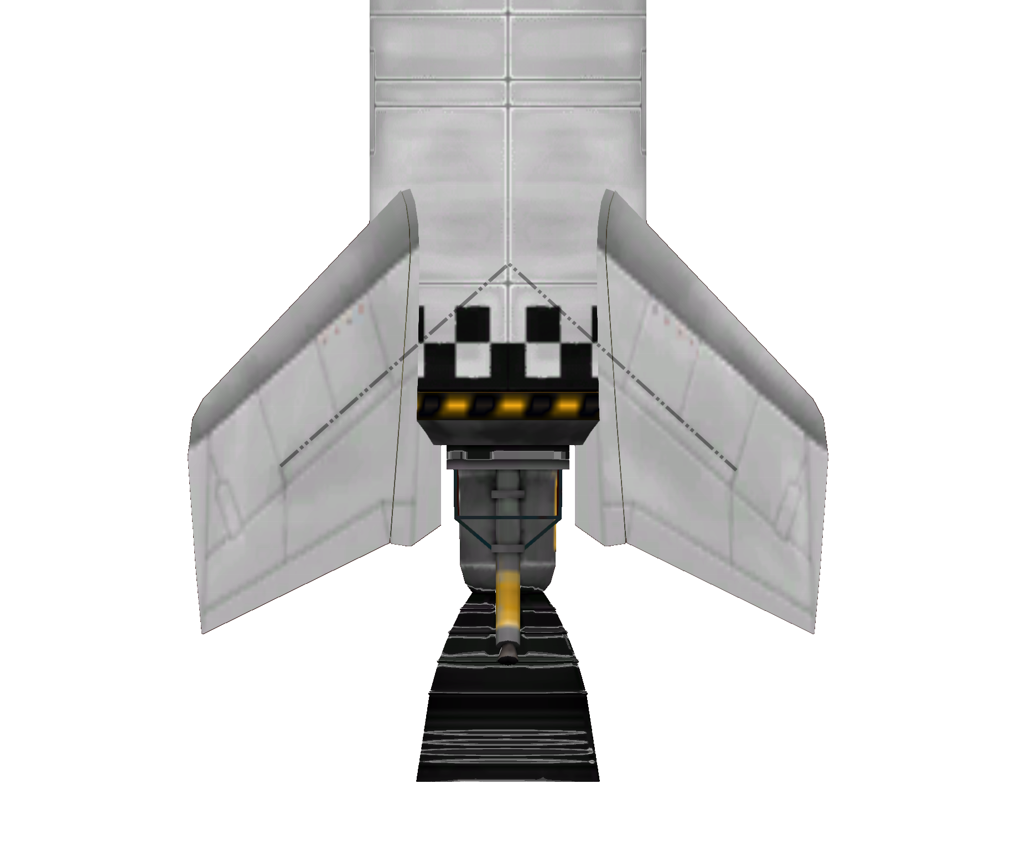
Illustration 1: High contrast picture of fin section, with reference extension line.
Under 4 way symmetry, take one AV-R8 Winglet. Using snap to position and 4 way symmetry, place four fins on a 45 degree angle to the Y and Z axes (cardinal directions NE, NW, SE and SW).
The fin height should be adjusted to match the picture to the right. As reference, when the fin position is correct, a line projecting from the short structural reinforcement above the middle full length one should intersect the first point (defined by the intersection of the square markings in the fuel tank) after the fin. The reference line should then intersect the top of the pattern, at the point between the one of the top-most squares that defined the first point, and the square immediately to the Z or Y axis.
Fins should be configured with a 30% control authority.

Booster decoupler installation
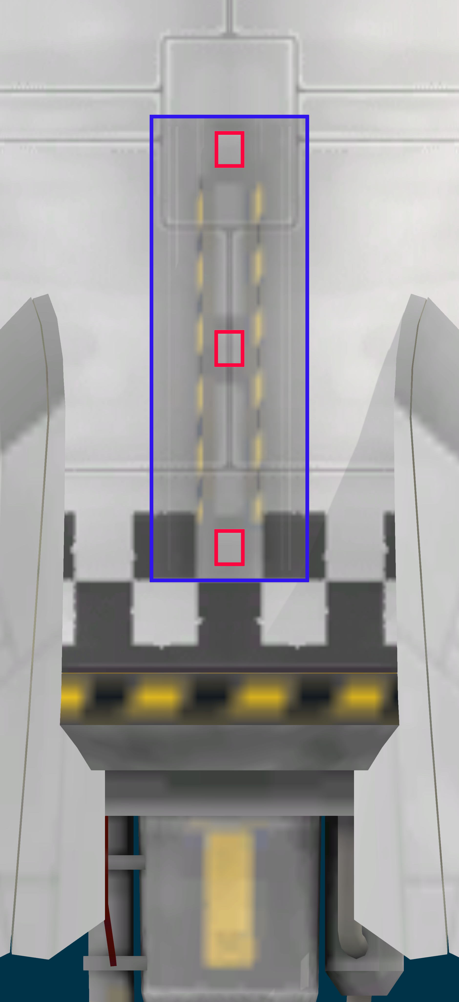
Illustration 2: Booster decoupler installation. Footprint highlighted in blue. Explosive bolts in red.
For boosted models, it is necessary to install radial decouplers that will act as support points for the boosters. The decouplers should be installed on the north and south sides using 2 way radial symmetry.
Using 2 way symmetry and angle snap, take a TT-38K radial decoupler and place over the north or south side. The decoupler should be mounted with the centre intersecting the plane defined by the X and Y axes. The FL-T400 tank has a seam in the position where the decoupler should be installed. This seam is interrupted at the top and bottom, as seen in the picture to the right.
Decoupler position along the rocket length can be easily determined by using the checker markings. The lower explosive bolt should be centred at the white square at the +-Y position.
Only R-3-1200 cores should be boosted. Boosting is not an option for R-3-400 and R-3-800 rockets.

B1 solid fueled booster installation
The B1 solid booster is built upon the RT-5 “Flea” solid rocket booster engine. The only other component is an aerodynamic nose cone.
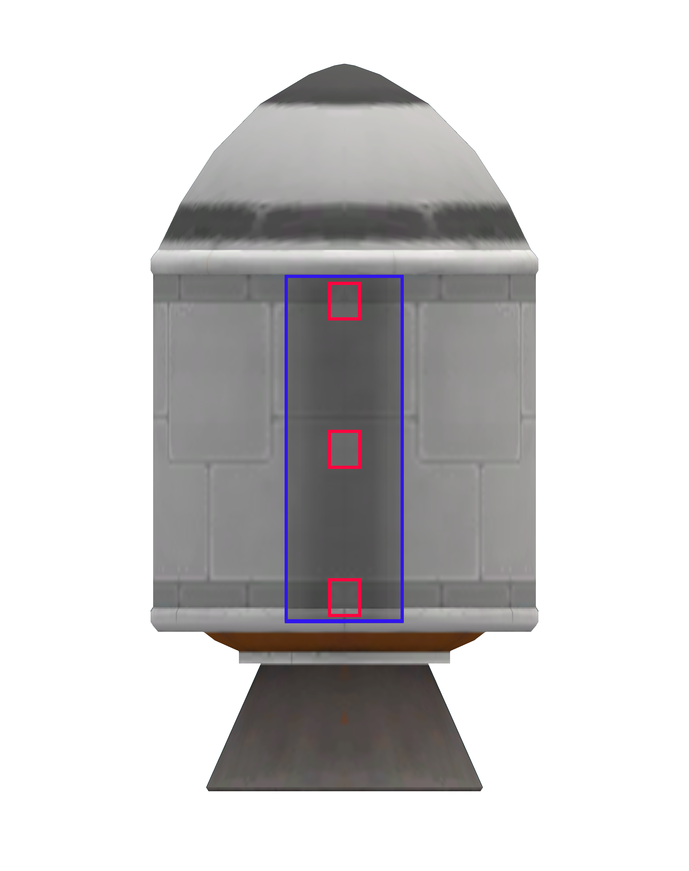
Illustration 3: B2 booster. Decoupler footprint in blue, explosive bolts in red.
Assembly is normally done by connecting a RT-5 solid engine to the lower stage decoupler. The decoupler should be installed over the full length of the fuel tank of the RT-5. The booster should be installed centred and the top of the decoupler should be over the grey line at the top of the fuel tank.
Once the booster is installed, the nose cone can be axially attached at the top.
The engine should then be configured to deliver 63% of the full thrust for use in the R-3 family.

L30-400 liquid fueled booster installation
The L30-400 booster is composed of a LV-T30 “Reliant” engine with a FL-T400 fuel tank and a basic nose cone on top. These components should be assembled axially.
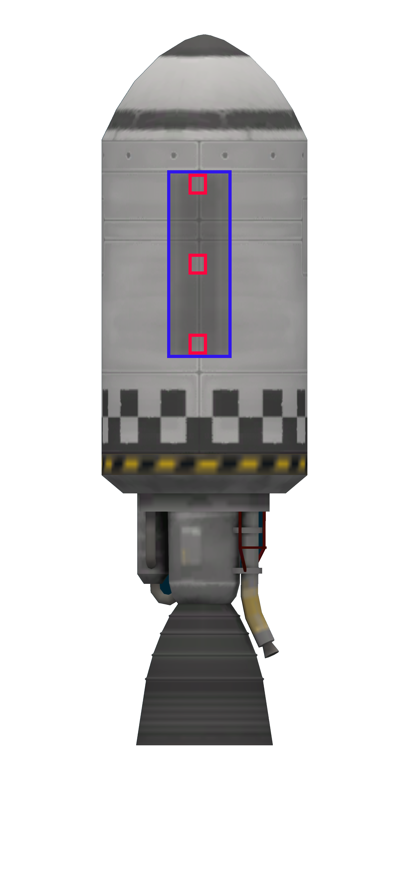
Illustration 4: L3-400 booster. Decoupler footprint in blue, explosive bolts in red.
To assemble a booster from individual components, connect a FL-T400 fuel tank to the lower stage decoupler. Immediately connect the nose cone and the engine to the fuel tank’s axial connectors.
Once the booster is assembled, move it along the radial decoupler until the top of the decoupler ends exactly at the riveted structure at the top of the tank (see picture to the right).
Once installed, set the engine thrust to 58% of maximum. This setting applies only to the R-3 family, other rockets may use a different configuration.

Upper stage
The R-3 family uses a single type of upper stage. This upper stage is powered by a LV-909 “Terrier” engine and fueled by a single FL-T400 liquid fuel tank.
The upper stage has 4 hardpoints in which additional equipment can be installed.

Upper stage core assembly
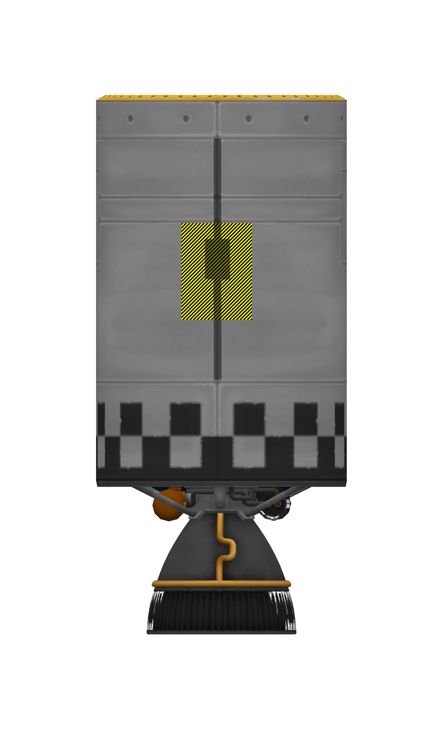
Illustration 5: Upper stage hardpoint, showing footprint for OX-STAT solar panel and Communotron 16-S antenna.
Upper stage core assembly is straightforward. Simply place a FL-T400 fuel tank over a Terrier engine axially. The engine should be set with a full thrust configuration.

Upper stage hardpoints
The upper stage has four hardpoints for external mounted avionics. The only external avionics currently available are the Communotron 16-S, OX-STAT solar panels and MechJeb’s AR202 case.
The communotron antenna should be mounted vertically, spanning the entire height of the three central panels. Its footprint is marked in black in the picture to the right.
The OX-STAT and AR-202 should be mounted immediately below the junction of the third to fourth panels, counted from the top, using the yellow footprint as a guide.
Both should be mounted using angle snap, with an orientation towards the cardinal points.
It should be noted that in the north and south faces of the rocket, the junction to be used as reference is partially interrupted by a square panel. The junction is present at the right and left sides of the hardpoint and should be used as a guide for mounting, ignoring the panel.

Payload section
Payload sections should be taken as-is from the KSS catalogued fairings.

LV type | Fairing | Mass | Uses
1 | A1 | 329 | General cargo, short fairing.
2 | A2 | 424 | General cargo, long fairing.
3 | A3 | 491 | General cargo, extra long fairing.
4 | B1 | 267 | AOC-3 launch.
5 | B2 | 323 | AOC-2 launch.

Cargo bays should also be configured as indicated in the fairings and cargo bay catalog. The following definitions are used in the R-3 family.

Cargo bay code | Description
F | Empty fairing, payload affixed to fairing base.
C | Capsule service module. Decoupler affixed to fairing base, capsule follows.
S | Single bay, as specified by fairing catalog.
D | Dual bay, as specified by fairing catalog.

Payload mass calculation
Payload mass should be corrected to account for the differences in avionics in each rocket model. Payload mass is calculated and tabled based on a flight tested model and the following adjustments should be made for each variation.

Type | F | +0 Kg
Type | C | +40 Kg
Type | S | +40 Kg
Type | D | +80 Kg
Computer | N | +0 Kg
Computer | J | +0 Kg
Computer | O | +100 Kg
Computer | H | +100 Kg
Stabilization level | 0 | +0 Kg
Stabilization level | 1 | +50 Kg
Stabilization level | 2 | +100 Kg
Communications | 0 | +0 Kg
Communications | 1 | +15 Kg
Power generation | N | +0 Kg
Power generation | O | +10 Kg
Power generation | P | +5 Kg
Power generation | Q | +15 Kg
Power storage | 0 | +0 Kg
Power storage | 1 | +10 Kg
Power storage | 2 | +50 Kg
Recovery | X | +0 Kg
Recovery | R | +100 Kg

Example
A 500 Kg satellite is being launched in the single payload bay of an R3-800-S1-H01P0R launcher rocket. Data is not known for this model, but is available for the R3-800-D1-H01N1X The following adjustments should be applied to the payload mass.

The model to be used is S1-H01P1R. This model has the following corrections applied.

Type S, single bay shrouded: add 40Kg.
Type H computer: add 100Kg to mass.
Stabilization level 0: no mass added.
Level 1 communications: add 15Kg.
Battery level 0 (OBC only): no mass added.
Single solar panel (type P): add 5 Kg.
Recoverable rocket: add 100Kg.

Total corrections: 260 Kg.

Adding 260Kg to the payload mass of 500Kg yields a 760Kg payload. This means that launching this mass on the R3-800-S1-H01P1R would be equivalent to launching 760 Kg on a hypothetical empty R3-800-N00N0X rocket.

We can then apply the same correction to the S1-H01N1X rocket.

Type S, single bay shrouded: add 40Kg.
Type H computer: add 100Kg.
Stabilization level 0: no mass added.
Level 1 communications: add 15Kg.
Battery level 1 (Z-200): add 10Kg
No solar panels: no mass added.
Expendable rocket: no mass added.

Total corrections: 165 Kg.

Subtracting the second value from the first gets us a 95 Kg difference. Therefore launching the 500Kg satellite on the R3-800-S1-H01P1R would be equivalent to launching a 665 Kg satellite on a R3-800-S1H01N1X.
This estimate only applies to internal cargo, and only with respect to and mostly applies to remaining delta V after launch. Components carried in upper stage hardpoints introduce a small drag penalty, and other flight characteristics are affected by the presence of the larger reaction wheel or different models of payload shrouds. Therefore, this calculation should not be used if the payload shroud changes of if the onboard reaction wheel model is changed, especially for light payloads. When adding hardpoint payloads, a small margin should be added to compensate for increased drag.

Mass table for flight tested hardware

Launch vehicle type | Mass
R3-400-S1-H01N1X | 7.184
R3-400-S2-H01N1X
R3-800-S1-H01N1X
R3-800-S2-H01N1X
R3-1200-S1-H01N1X
R3-1200-S2-H01N1X
R3-1200B-S1-H01N1X
R3-1200B-S2-H01N1X
R3-1200L-S1-H01N1X
R3-1200L-S2-H01N1X

Payload integration
Once the rocket is assembled, the payload should be integrated into the stack. Integration in its simplest for is just taking the payload (or payloads for dual launches) and attaching it to the payload bay decoupler.
The rocket comes with TD-12 payload decouplers. The couplers have a default position defined by in the payload catalog, but they may be changed as needed for each specific mission. However, using the predefined decoupler configurations help achieve a repeatable performance.
Weight saving measures can be implemented in the payload integration phase. These involve minor modifications to the payload interface with the rocket.
- Replacing the TD-12 decoupler with a TD-06 one, entails a reduction of 30Kg per replacement.
Payload decouplers may be replaced by separators, at a small mass penalty (10Kg per separator). Separators create debris during operation, and are not recommended for payload launches in orbit. If a separator is to be used, replace the upper bay decoupler with one, and readjust the lower bay decoupler’s ejection force to 100. Use of separators in the lower payload bays is not necessary, as recovery parachutes deploy through the lower separator by design.
For payload mass limits, see each the data pertaining each specific variant’s performance data. Payload volume data is available in the fairing catalog.

Requires MechJeb plugin to work.
P and Q power systems are not compatible with J type computers.

